Connect UDI with BUDI – Version 2025/01
Table of contents

1 Connect UDI with BUDI – Version 2025/01 1
2 Change history 2
3 Support und contact information 2
4 Introduction 3
4.1 Individual Assigment 3
4.1.1 Maintain UDI-DI 3
4.1.2 Device (Connect with Basic UDI) 3
4.2 Assigment BUDI to UDI-DI 4

Change history

Version | Date | User | Description

Support und contact information

A support request is usually made by e-mail. In urgent cases you can call us.

E-Mail: support@europe-it-consulting.ch

Phone: +41 61 508 73 34

Web: https://www.europe-it-consulting.ch

Address:

EUROPE IT Consulting GmbH
Steinentorstrasse 35
4051 Basel
Switzerland

Introduction
There are two ways to link the UDI-DI with the Basic UDI: individual assignment via the UDI-DI, or mass linking via the Basic UDI.

Individual Assigment

Maintain UDI-DI

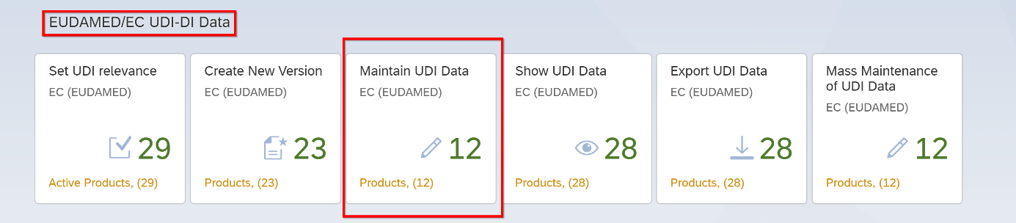
- Access the "Maintain UDI Data" Application.

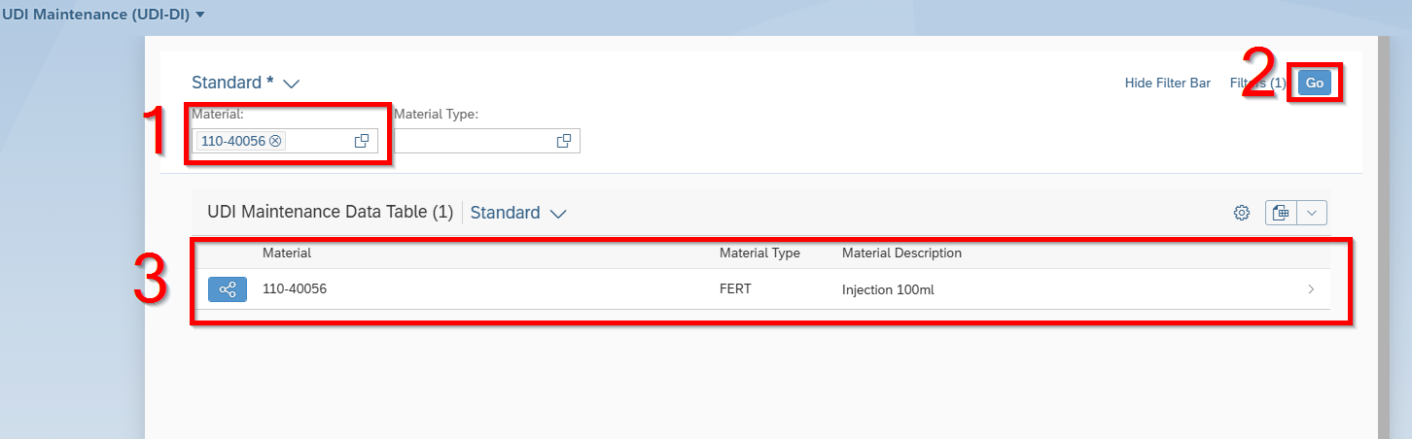
- Fill in the Material number
- Click on “Go”
- Select the Material

Device (Connect with Basic UDI)

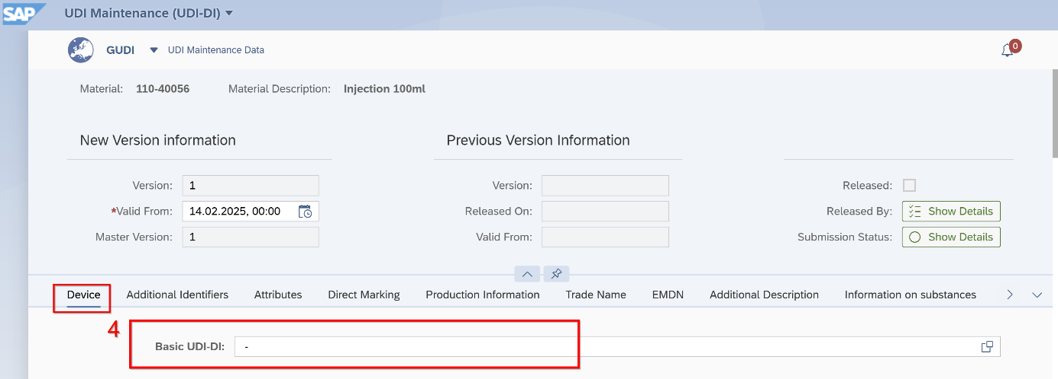
- Click in Basic UDI-DI

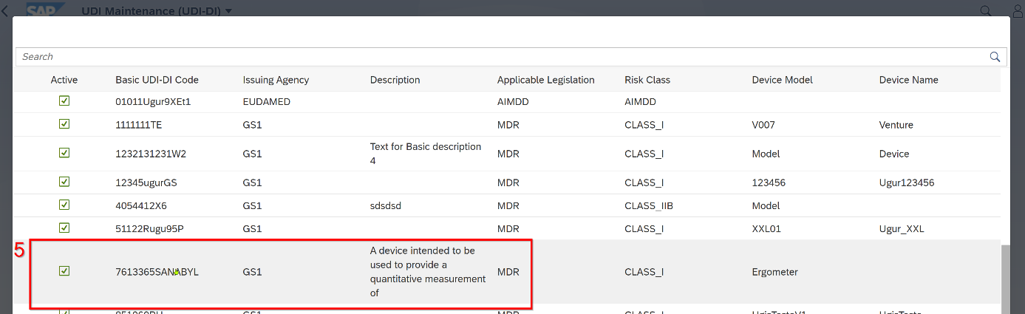
- Choose the Basic UDI-DI number which you want to connect to the material

Assigment BUDI to UDI-DI

It is also possible to subsequently link UDI-DI data that has already been created and has not been assigned to a BUDI with the BUDI.
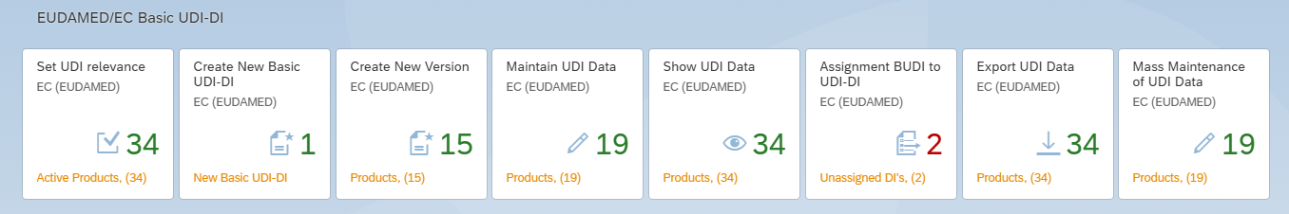

- Please open the “Assignment BUDI to UDI-DI” application
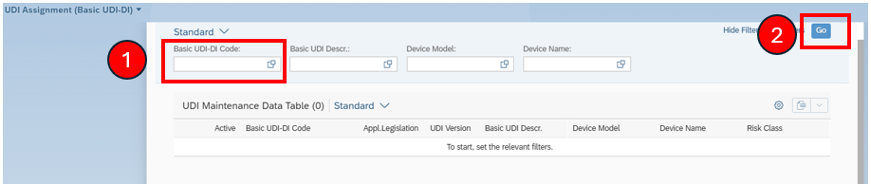
- If you know the Basic UDI-DI code, please type in here.
- If not, please click on go.
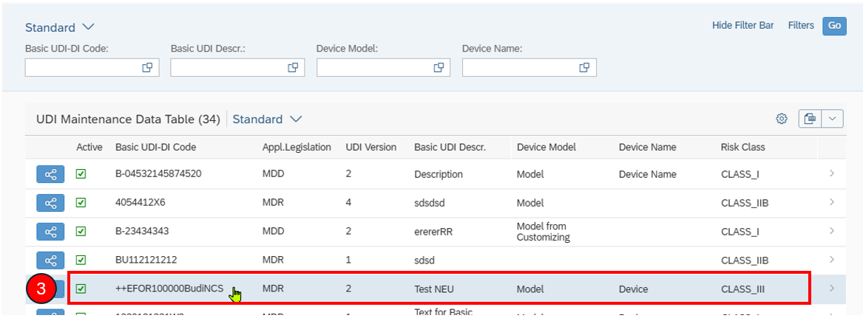
- Click on the Basic UDI-DI which you would like to link with the UDI-DI.

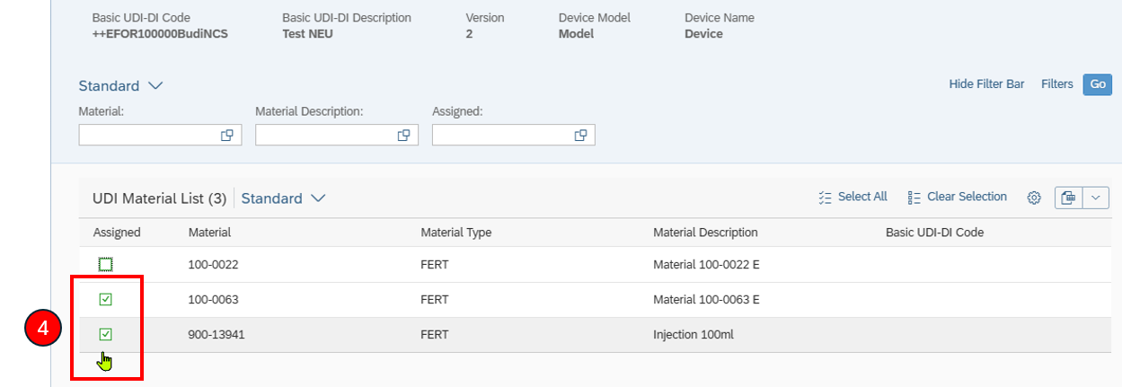

- Assign the UDI-DI(s) and click on “Save”
After these steps the UDI-DI(s) is(are) linked to the Basic UDI-DI. Next steps are to “Start Release Workflow” and continue with “Release UDI Data”.

